GROUP MEMBERS
ST10303074
RICHARD SIBOMANA
GRoup 6 Planning and research
OPSC6311

Contents
Introduction 1
App Overview 1
Name of the application 1
Initial Icon Design 1
Description of innovative features 2
Requirements for BudgetIQ application 2
User interface design 5
Project plan (Gantt Chart) 16
Conclusion 17
References 18

Introduction
Are you frustrated of dealing complex budgeting applications that makes you feel stressed out more than ever? Let’s introduce you to BudgetIQ, the intelligent and user-friendly personal finance application that will make your life easier with handling your finances. Using BudgetIQ makes it easier for you manage your spending, give you the opportunity to set customised budget targets, and make you understand your spending behaviour. Utilise our unique progressive dashboard to monitor your progress towards financial achievement, attaching receipt images for easier record keeping, and log expenses while on the go. To keep you motivated, we added fun gamification elements. Now, are you ready to take over your finance and fulfil your goals?

App Overview

Name of the application
BudgetIQ

Initial Icon Design
The application will emphasise on user empowerment and financial clarity which will be reflected by BudgetIQ’s simple and minimalistic style icon.
- A circular shape with a dark background
- An overlapping pie chart in the centre
- A simple readable app name written in bold at a small size.

Description of innovative features
- Advanced analytics
- Category insights - view all amounts of money spent within each category in the duration of the customised time spans.
- Visual expense trends - A interactive graph that assist them to spot trends by showing everyday spending trends spanning the user’s selectable period of time
- Gamification elements
- Reward system - Receive a badge or points for consistently recording expenses or reaching financial goals
- Saving tiers - Obtain rewards by meeting a certain saving target, for example 20% saving target.
- Progress dashboard
- A visual display of how well the user is staying within their spending budget limits on the dynamic dashboard
- Highlight categories that are overspending for a quick attention

Requirements for BudgetIQ application
- User registration and login
System requirement
- User must be able to log in using a username and password.
Detailed explanations
- Username, password, and email address fields must be included in the registration.
- Password encryption is recommended using safe hashing techniques.
- Offer users a secure “forget password” option for them to change their passwords.
- Expense Categories
System requirement
- The user must be able to create custom categories for expense (e.g., “Groceries”, “Entertainment”, “Transport”).
Details explanation
- Give users the option to add, edit, and remove categories, however preset categories for first use must be provided
- Recommend for categories to be linked to the spending entries and should be stored in the local database
- Adding expenses
System requirement
- User must be able to add expense entries by specifying at least the amount, date, description, and category.
Detailed explanation
- Amount field should have numbers input that allows currency format
- A drop-down menu or list for selecting a category
- Selection of the transaction date by a date piker
- For adding a description, a text field has to be added
- Options to attach an image of a receipt in JPEG or PNG format
- Receipt uploads
System requirement
- User must be able to optionally attach photos of receipt to expense entries
Detailed explanation
- Implement a feature which enables users to capture image within the app or upload them via their phone’s gallery.
- To minimise space loss without losing quality, images must be compressed before saving them
- Save receipt images in a secure local database and link them to necessary expenses entries
- Monthly budget goals
System Requirement
- User must be able to set a total monthly budget goal and specific limits for individual categories
Detailed explanation
- Provide a numeric input fields in order for the budget targets to be defined
- Make users specify their own limit for spending for each category
- Utilise pie charts or progress bars to visualise the progress on the dashboard
- Expense history viewing
System requirement
- User must be able to view a list of all expenses during a user selectable period
Detailed explanation
- Add date range filters
- Show expense essential information like, amount, date, category and description in card or table format
- Provide users with access to receipt by clicking an entry if photo was uploaded
- Spending insight by category
Requirement
- User must be able to view the total amount spent on each category during a user-selectable period
Details
- Created or generate a summary report displaying all total amounts spent per category
- Utilise a pie or bar chart to present the breakdown of spending by categories.
- Data storage
System requirement
- All data must be saved locally in a database
Detailed explanation
- Implement appropriate indexing and ensure data integrity for every relationship, example, associating expenses with categories
- Spending trends graphs
System requirement
- User must be able to view the graphs showing daily spending over user-selectable periods
Detailed explanation
- Use bar charts to demonstrate everyday spending trends over time.
- Give users the option to select a time period of their own for analysis
- Visual Indicate excessive spending
- Progress dashboard
System requirement
- Display a dashboard showing how well users are staying within their budget goals for the current month
Detailed explanations
- Use warning colours such as red to alert focus on the area where there is overspending
- Including visual indicators to show total budget goal versus budget utilisation per category and overall spending.
- Gamification elements
System requirement
- Include gamification features such as rewards or badges for meeting budget goals or consistent expenses logging.
Detailed explanations
- Offer badges such as “Budget Master” for remaining under the budget
- Let users share their achievements across their social media platforms

User interface design
GET STARTED
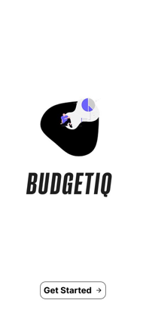
Once the user clicks the get started button the will be taken to the login page
LOGIN AUTHENTICATION
Screen 1
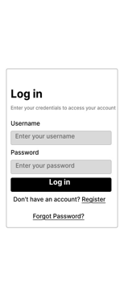
The user will be required to login if the already have an account, if not they can click the underlined word “Register” which will redirect the to a register page.

Screen 2
The user will create a new account to be able to login in the app

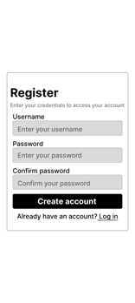
DEFAULT DASHBOARDS
These dashboards will display the total spent out of the budget goals the sets, budget status of all categories within the budget and the achievements the user has acquire while using the application. Will also allow the user to select any expenses from any date.
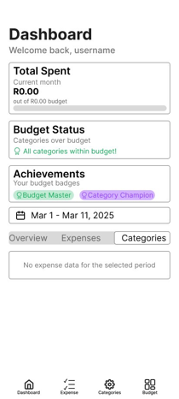
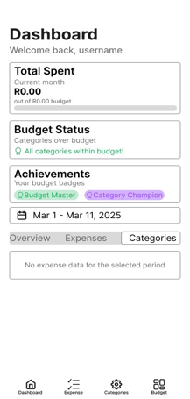
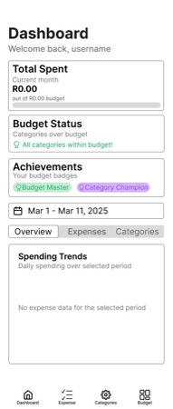

ADD NEW EXPENSES
Screen 1
when a user clicks the expense button they will land on this page where they will be required to add their recent expense.
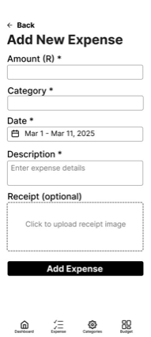

Screen 2
On second screen of the expense section, the user will be required to add a category of their expense
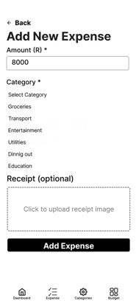
Screen 3
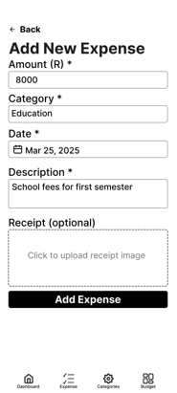
The user will be required to add the date of when the expense happened and as description of the expense

Screen 4
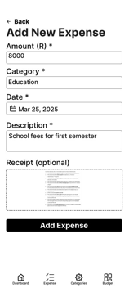
The user can choose to have to add or not to add a receipt of their expenses.

Screen 5
A prompt will pop up to let the user know that the expense has being added

EXPENSE CATEGORIES
Screen 1
User may add categories which they can edit or delete anytime they wish to.
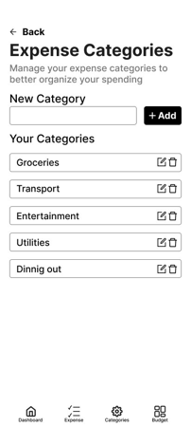
Screen 2
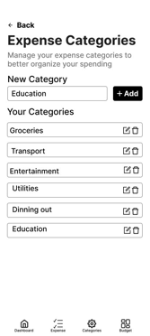
The user will have to add a new category which will appear with the default categories offered by the application.

Screen 3
This screen will prompt the user that the category is successfully added


Screen 1
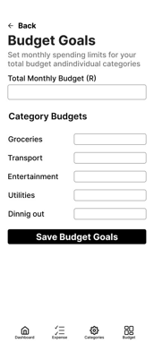
The application will offer user to set their total monthly budget goal

Screen 2
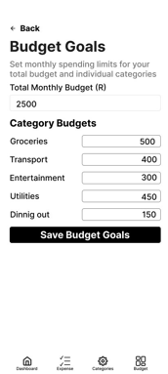
Users can set their budget limits by categories

Screen 3

The user will receive a prompt message that the budget goal is set

UPDATED DASHBOARDS
These dashboards will display the updated total spent out of the budget goals the set, budget status of all categories within the budget and the achievements the user has achieved. Will also allow the user to select any expenses from any date.
Screen 1
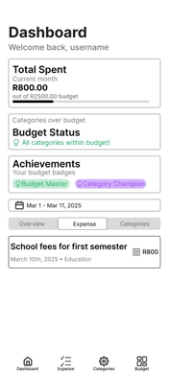
When the clicks the expense button, the added expense will appear with the description, date and category the user chose with a receipt icon next to the amount of the expense.

Screen 2
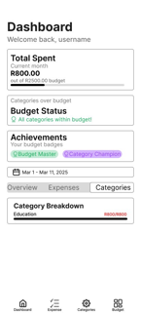
The user can be able to see the category breakdown when they click the categories button

VIEW RECEIPTS

When the icon next to the expense account is clicked, it will take the user to this page

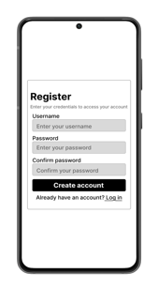
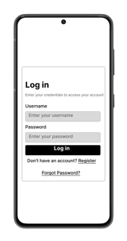
Mockups
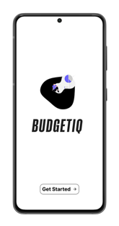

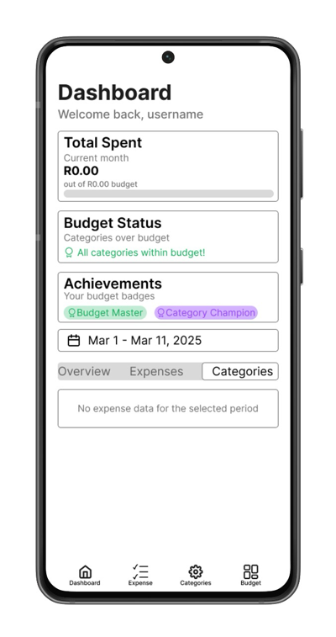
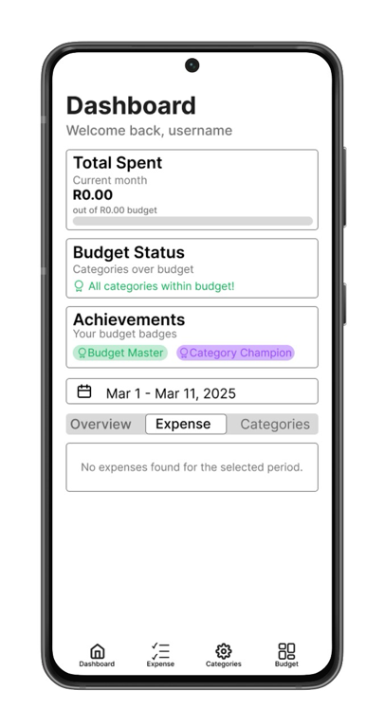
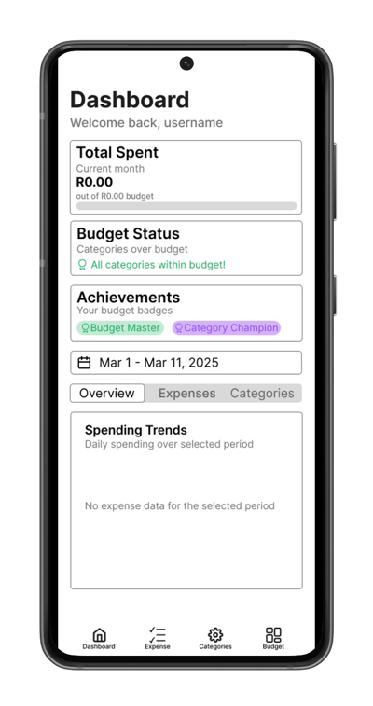

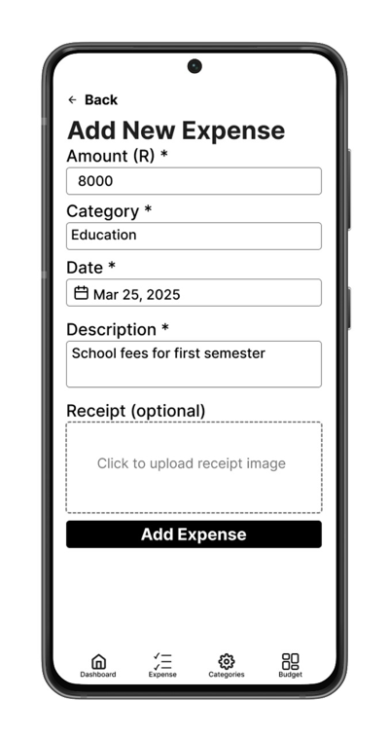
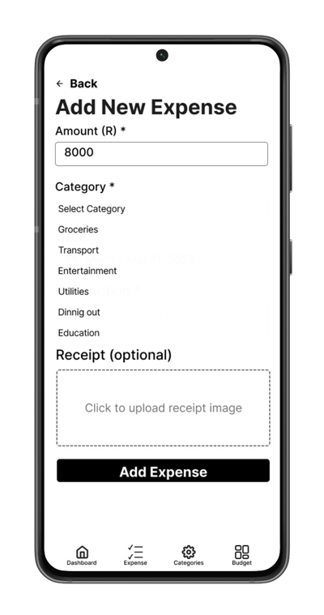
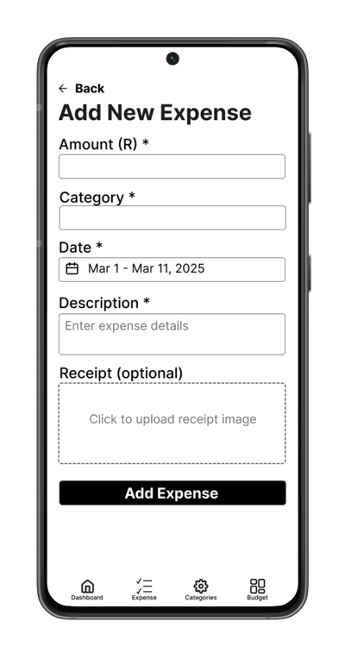

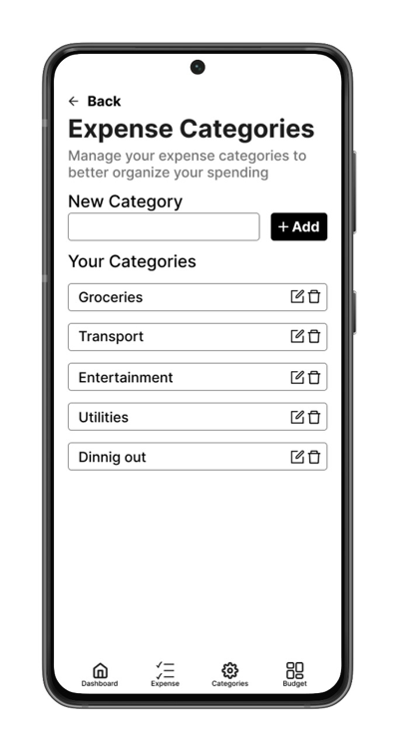
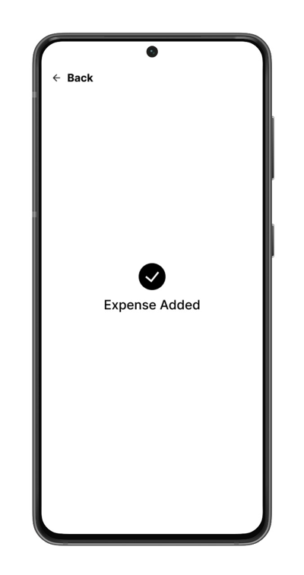
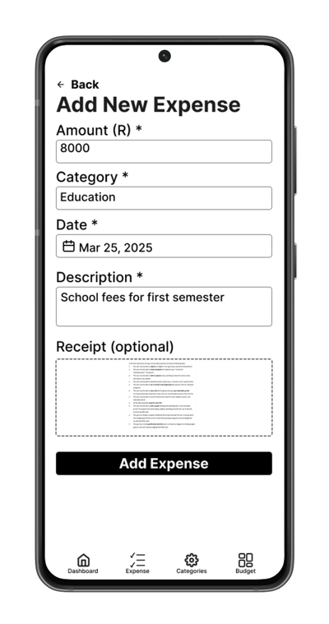

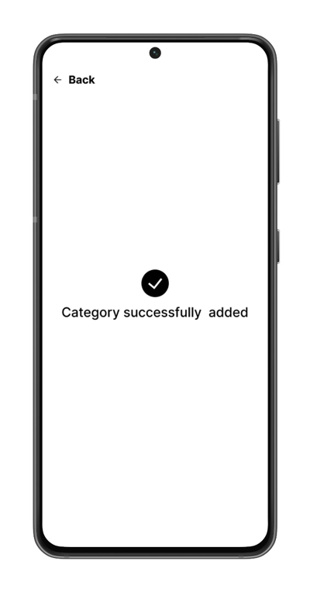
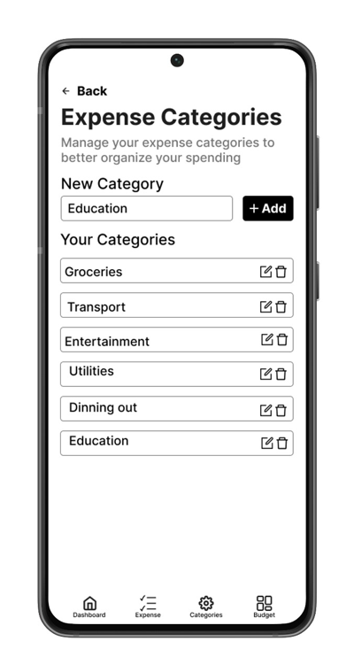
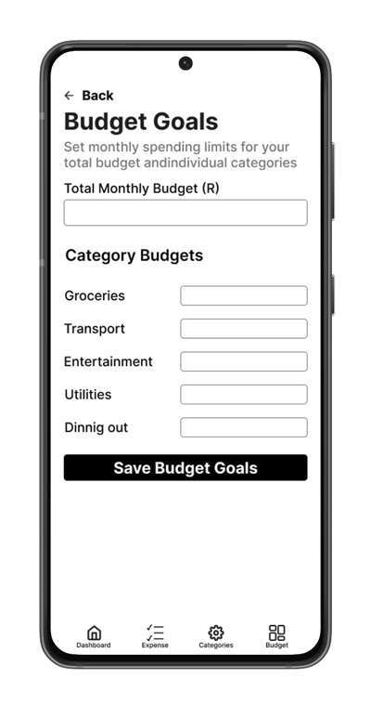

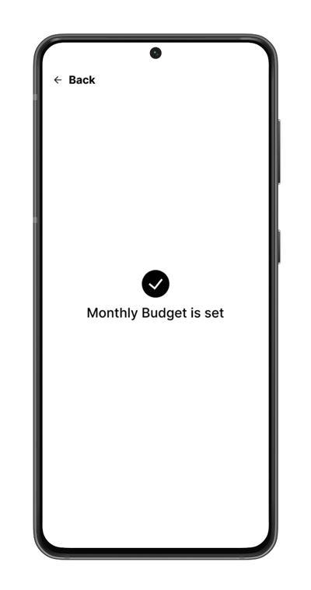
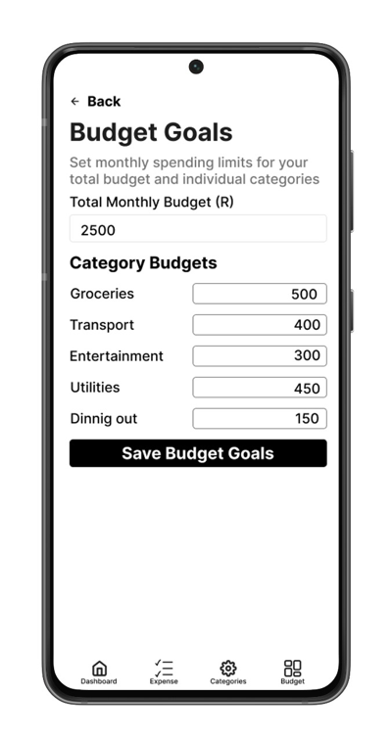
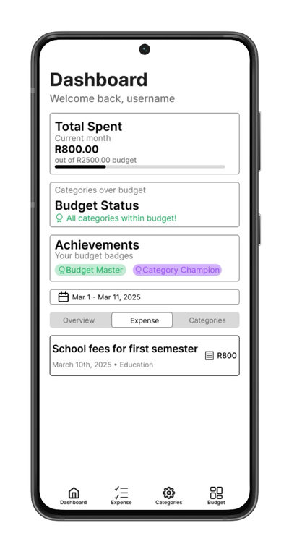

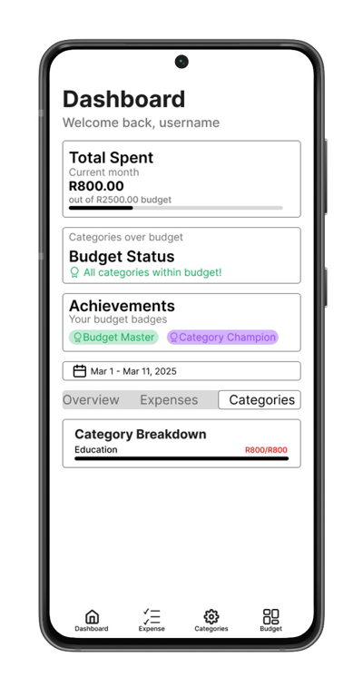
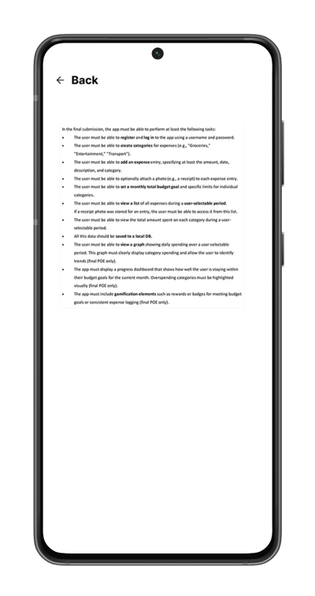

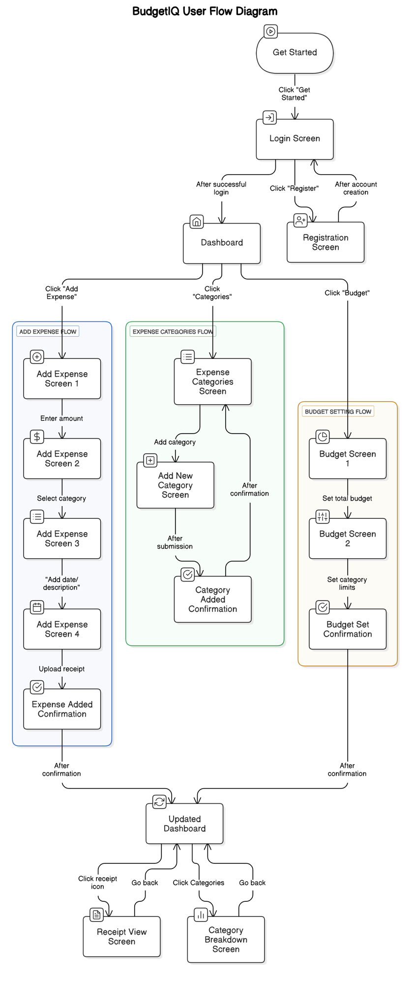
Navigation Diagram (users flow chart)

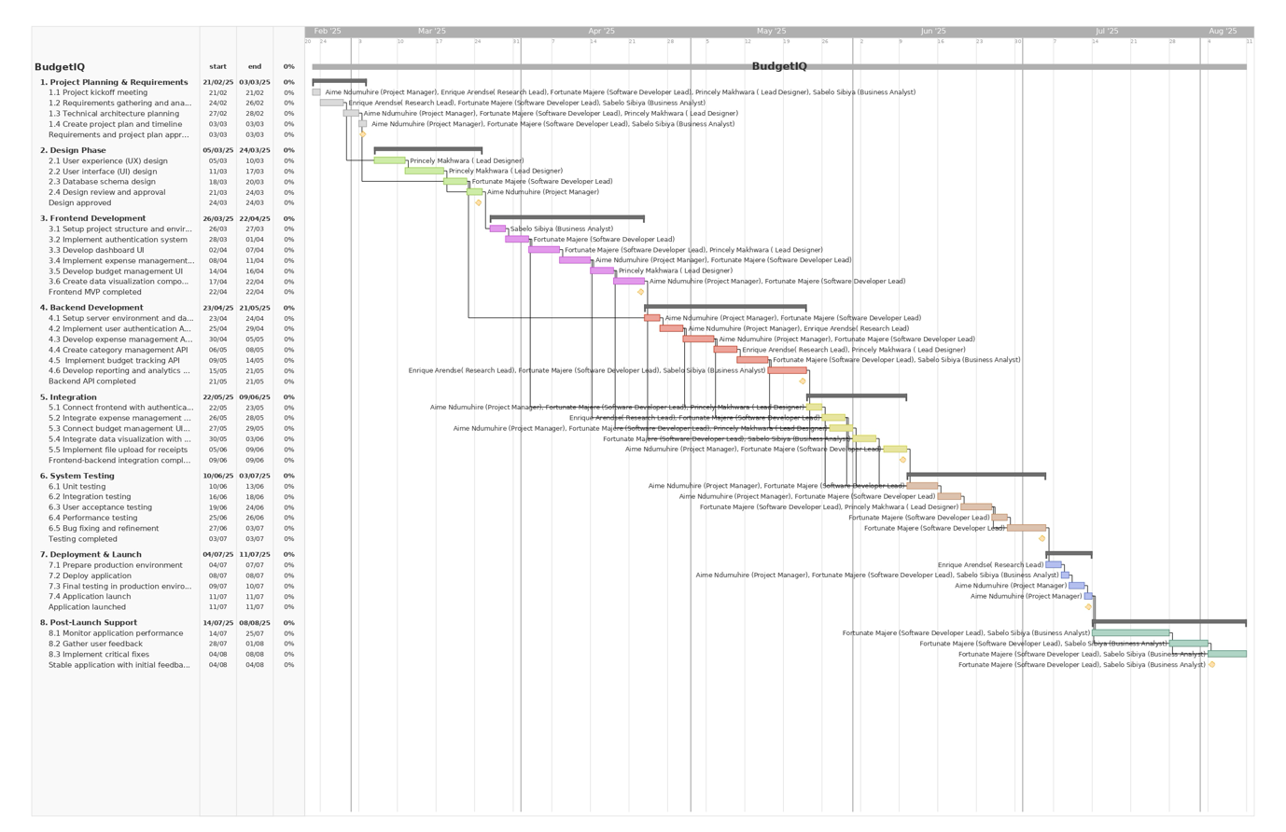
Project plan (Gantt Chart)

Link to Gantt Chart:
https://prod.teamgantt.com/gantt/schedule/?ids=4242471&public_keys=B40OOh24bHfK&zoom=d100&font_size=12&col_width=355&documents=0&comments=0&estimated_hours=0&assigned_resources=0&percent_complete=0&hide_header_tabs=0&menu_view=1&resource_filter=1&name_in_bar=0&name_next_to_bar=0&resource_names=1#

Conclusion
Conclusion
To conclude, BudgetIQ is highly effective and easy to use application designed for managing personal finances smoother. in BudgetIQ users are granted the opportunity to take control of their finances merging cool features such as visual insights, gamification, and receipt attachments with the basic budget functionalities like budget goal setting, expense tracking and creating categories. BudgetIQ ensures its users reach their financial goals without losing inspiration all thanks to is user friendly User interface, storage of information and an appealing progress tracking. BudgetIQ is your wise companion for your financial success whether you are trying to save up for your big purchase or managing your usual expenses.

References
Equifax.com. (2024). Budgeting Apps: What Are They & How They Work | Equifax. [online] Available at: https://www.equifax.com/personal/education/personal-finance/articles/-/learn/budgeting-apps/.(Accessed: 09 March 2025).
Baus, A. (2022) Key features to consider when developing a personal finance app, /article/personal-finance-app-features/. Available at: https://decode.agency/article/personal-finance-app-features/ (Accessed: 01 March 2025).
Clare (2020) How gamification can help you to build positive spending habits, with Clare Seal, gamification-can-help-to-build-positive-spending-habits. Available at: https://www.giffgaff.com/blog/gamification-can-help-to-build-positive-spending-habits (Accessed: 27 March 2025).
iOS App Store Optimization (ed.) (2024a) iOS app icon sizes and best practices (2024 update), ios-app-icon. Available at: https://appradar.com/academy/ios-app-icon (Accessed: 02 March 2025).
Johnson, R. (2023) The Impact of Gamification in Finance SaaS: Engaging User Experiences, blog/gamification-in-finance-saas/ Available at: https://www.itilite.com/blog/gamification-in-finance-saas/ (Accessed: 28 March 2025).
Pandya, J. (2024) Personal Finance Management App Development: A Comprehensive Guide, blog/personal-finance-app-development-guide. Available at: https://www.expertappdevs.com/blog/personal-finance-app-development-guide (Accessed: 21 March 2025).
Petruk, M. (2023) How to Make a Budget App: From Features to Design Considerations, /budget-app-development-essential-features-and-monetization-strategies. Available at: https://wesoftyou.com/fintech/budget-app-development-essential-features-and-monetization-strategies/ (Accessed: 14 March 2025).
Piyali (2022) Top 13 must-have features for your expense tracking app, top-13-must-have-features-for-your-expense-tracking-app. Available at: https://materialplus.srijan.net/resources/top-13-must-have-features-for-your-expense-tracking-app (Accessed: 25 March 2025).
Srabanika, S. (2022) Designing a finance tracker app, designing-a-finance-tracker-app. Available at: https://medium.muz.li/designing-a-finance-tracker-app-be24ad13ea0f (Accessed: 28 March 2025).
Varhatiuk, K. (2025) How to Make an App Icon:12 Tips from Experts (2024), blog/how-to-make-your-own-app-icon/. Available at: https://fireart.studio/blog/how-to-make-your-own-app-icon/ (Accessed: 31 March 2025).
.

